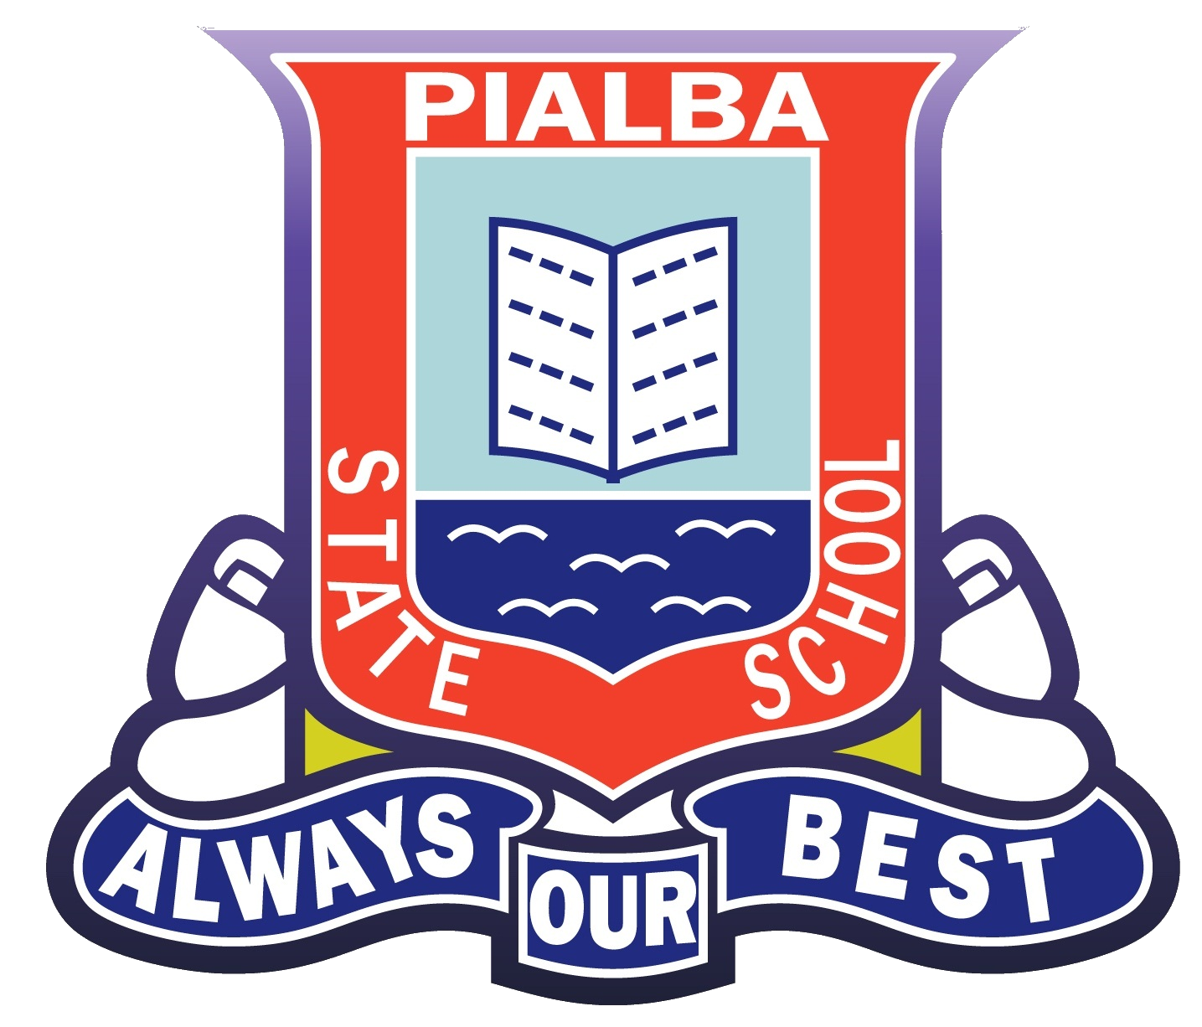
Pialba’s SunSmart policy

This policy applies to all school events on and off-site.

Rationale
Too much of the sun’s UV can cause sunburn, skin and eye damage and skin cancer. UV damage accumulated during childhood and adolescence is strongly associated with an increased risk of skin cancer in later life. Australia has one of the highest rates of skin cancer in the world, with two in three Australians developing some form of skin cancer before age 70.

Purpose
This SunSmart policy provides guidelines to:
- ensure all students and staff are protected from over-exposure to UV radiation;
- ensure the outdoor environment provides shade for students and staff;
- ensure students are encouraged and supported to develop independent sun protection skills to help them be responsible for their own sun protection;
- support our school’s strategies to meet its duty of care and occupational health and safety obligations to minimise harmful UV exposure for students, staff and visitors.

Legislation and Standards
- Occupational Health and Safety Act 2004
- Education and Training Reform Act 2006: Sch.5 Reg. 1 (1.2)

Procedures
- To assist with the implementation of this policy, staff and students are encouraged to access the daily local sun protection times via the SunSmart widget on the school’s website, the free SunSmart app, or at sunsmart.com.au .

- The sun protection measures listed are used for all outdoor activities during the daily local sun protection times.

The sun protection times are a forecast from the Bureau of Meteorology for the time of day UV levels are forecast to reach 3 or higher. At these levels, sun protection is recommended for all skin types. In Victoria, UV levels regularly reach 3 or higher from mid-August to the end of April.

Environment

Seek shade

- The school P and C Association in conjunction with the Principal, Groundsman and WPH&S Committee makes sure there are sufficient shelters and trees providing shade in outdoor areas particularly in high-use areas e.g. where students have lunch, canteen, assemblies, sports, outdoor lessons and popular play spaces.
- The availability of shade is considered when planning all other outdoor activities and a risk assessment is completed through an excursion planner.
- Students are encouraged to use available areas of shade when outside.
- Students who do not have appropriate hats or outdoor clothing are asked to play in the shade or a suitable area protected from the sun.
- In consultation with the school P and C Association, Principal and Education Facilities Department, shade provision is considered in plans for future buildings and grounds.
- A shade assessment is conducted regularly to determine the current availability and quality of shade.

Behaviours

Slip on sun protective clothing

- Cool, loose-fitting, sun protective clothing made of densely woven fabric is included in our school uniform / dress code and sports uniform. It includes shirts with collars and elbow-length sleeves, longer dresses and shorts and rash vests or t-shirts for outdoor swimming

Slap on a sun protective hat

- All students and staff wear hats that protect their face, neck and ears (broad-brimmed or bucket hat), whenever they are outside. Peak caps and visors are not considered a suitable alternative.

Slop on sunscreen

The school supplies SPF30 (or higher) broad-spectrum, water-resistant sunscreen for staff and student’s use.
- Sunscreen is applied in accordance with the manufacturer’s directions (applied at least 20 minutes before going outdoors and reapplied every two hours, or more frequently if sweating or swimming).
- Strategies are in place to remind students to apply sunscreen before going outdoors (e.g. reminder notices, teacher reminders, sunscreen monitors, sunscreen buddies).

Slide on sunglasses

- Where practical students wear close-fitting, wrap-around sunglasses that meet the Australian Standard 1067 (Sunglasses: Category 2, 3 or 4) and cover as much of the eye area as possible.

Learning
- Programs on sun protection are included in the curriculum for all year levels through the HPE Australian Curriculum.
- Students are encouraged to be involved in initiatives to promote and model sun protection measures to the whole school community.
- SunSmart behaviour is regularly reinforced and promoted to the whole school community through newsletters, school website/intranet, Facebook, staff and parent meetings, school assemblies, student and teacher activities and at student enrolment/new staff orientation.

OHS
- As part of OHS UV risk controls and role-modelling, staff, families and visitors:
- wear a sun protective hat, covering clothing and, if practical, sunglasses;
- apply sunscreen; and
- seek shade whenever possible.

Monitoring and review
- The School Principal, Health and Physical Education Teacher, Deputy Principal, WPH&S Advisor and staff monitor and review the effectiveness of the SunSmart policy and revise the policy when required (at least once every three years) by completing a policy review and membership renewal with SunSmart at sunsmart.com.au.
- The SunSmart policy is available to staff, students, families and visitors through induction packs and is embedded in Staff induction beginning of year presentations.

Next policy review: January 2021

Relevant documents / links
- DET School Policy & Advisory Guide (SPAG) Sun & UV protection (2019)
- Victorian School Building Authority Building Quality Standards Handbook (BQSH): Section 5.1.4 Shade Areas (2018)
- DET Outdoor activities (2018)
- Catholic Education Commission of Victoria (CECV) Your Child’s Health Wellbeing and Safety (Primary)
- Independent Schools Victoria (ISV) Managing a school – Health & Safety Compliance Framework: OHS >Sun Protection
- Victorian Early Years Learning and Development Framework (VEYLDF) (May 2016)
- Victorian Institute of Teaching (VIT) The Victorian Teaching Profession Code of Conduct - Principle 3.2
- Australian Professional Standards for Teachers (APST) – Standard 4.4 and 7.2
- Education and Training Parliamentary Committee Inquiry into Dress Codes and School Uniforms in Victorian Schools –Final Report (2007)
- ARPANSA Radiation Protection Standard for Occupational Exposure to Ultraviolet Radiation (2006)
- Safe Work Australia: Guidance Note – Sun protection for outdoor workers (2016)
- AS 4174:2018 Knitted and woven shade fabrics
- AS/NZS 1067.1:2016, Eye and face protection - Sunglasses and fashion spectacles
- AS/NZS 4399:2017, Sun protective clothing - Evaluation and classification
- AS/NZS 2604:2012 Sunscreen products - Evaluation and classification
- Australian Government Therapeutics Goods Administration (TGA) – Australian regulatory guidelines for sunscreens: 4. Labelling and advertising – directions for use of the product
- AS/NZS 4685.0:2017, Playground equipment and surfacing - Development, installation, inspection, maintenance and operation.6.2.1: General considerations, 6.3.9: Shade and sun protection, Appendix A: Shade and sun protection
Last updated: Mar 2019
E: sunsmart@cancervic.org.au
P: 9514 6415
W: sunsmart.com.au

